EX NO 2: CONFIGURE VLANs AND INTER-VLAN ROUTING IN PACKET TRACER
Ex No 2.1:
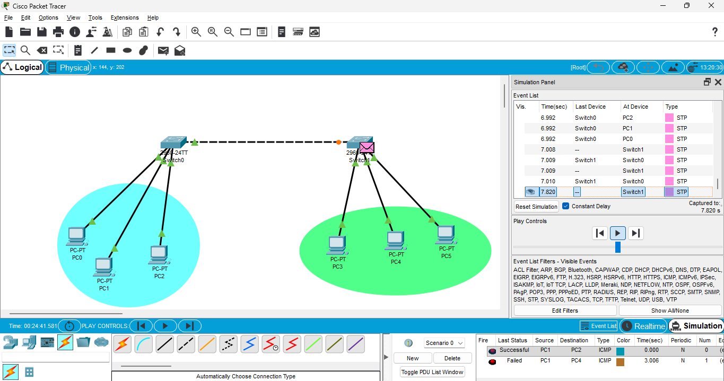
Ex No 2.2:
